Use the bitmap.c and bitmap.h files completed in class as your starting files. Add function prototypes as necessary to the bitmap.h file.
Code the following functions:
- Cropping an image reduces the image to the size indicated by bounding points in the upper left and lower right of a rectangle. Code a function to crop a bitmap image given upper left and lower right pixel coordinates as well as an image itself. A new image is returned.
IMAGE Crop (IMAGE * imgPtr, int xLeft, int yLeft, int xRight, int yRight)
- Rotating an image by an angle Θ (theta) measured in radians involves the use of formulas learned in the math class. So, assuming that the bottom left corner of the image is the origin (0,0) then the formulas to rotate about the origin are (x,y is the original location, and x’,y’ are the new location):
x’ = x * cos Θ - y * sin Θ
y’ = x * sin Θ + y * cos Θ
To rotate about a specific point Px, Py, we first translate to the origin, rotate and then translate back. The formulas then become:
x’ = (x - Px) * cos Θ - (y - Py) * sin Θ + Px
y’ = (x - Px) * sin Θ + (y - Py) * cos Θ + Py
The basic idea is to take a pixel from the original image, calculate its new position and set it into the new image. Now supposing the new image is the same size as the original, this would imply that some pixels will end up “out” of the image. In this case, the pixel is discarded.
Write a function that will take a pointer to an image and an angle (in radians) and returns a new image, the same size as the original, but rotated around the center of the image.
IMAGE RotateImage(IMAGE * imgPtr, float theta)
See next page for example images:

Original Bike image
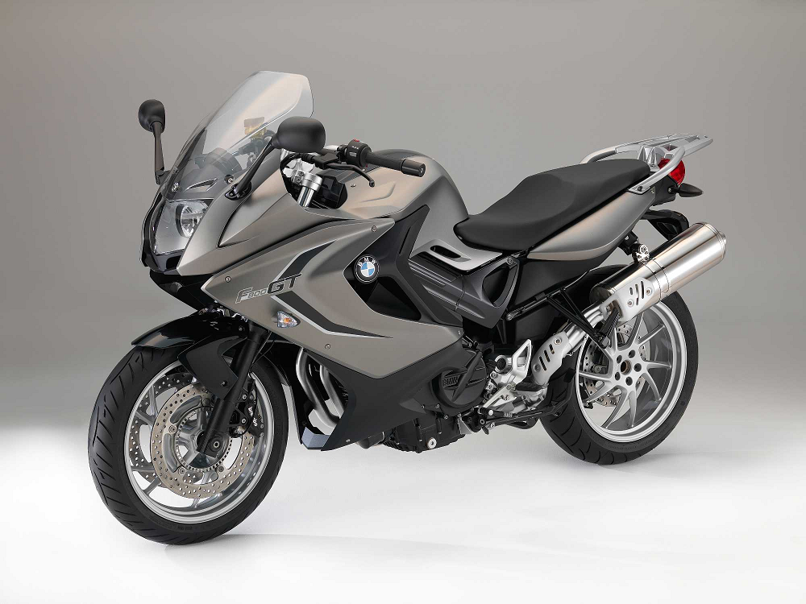
Bike rotated 45º counterclockwise.
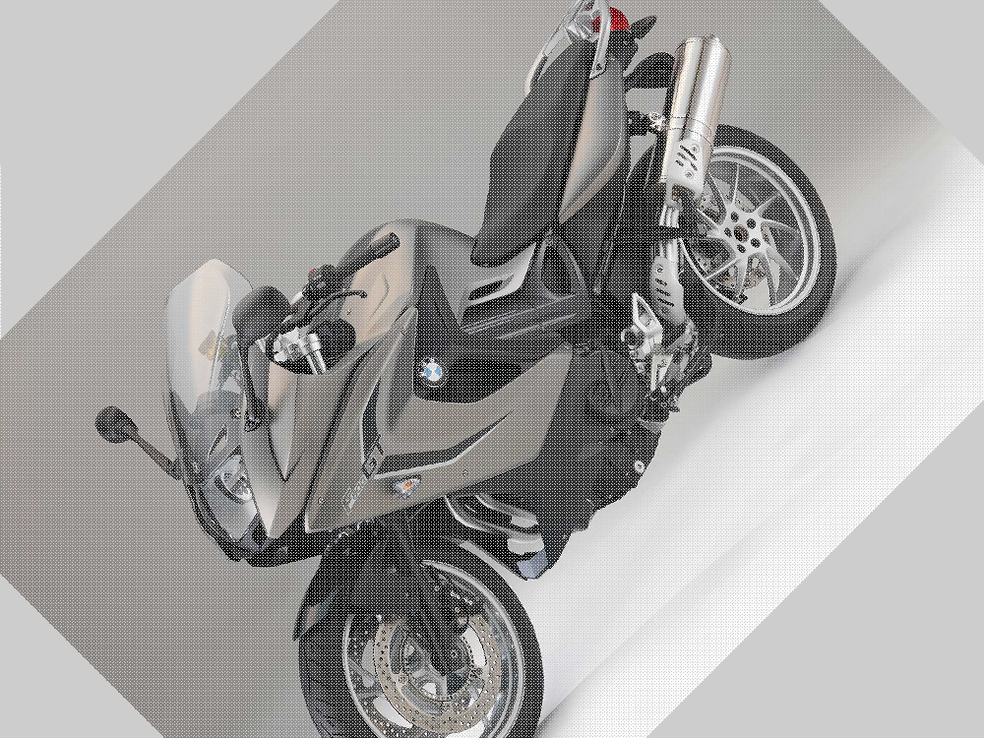

Things to note:
- Notice the faint white pixels in the result. This is called aliasing. Why do you think these white pixels exist? Make an attempt to solve this problem.
- Notice that locations where no image data exists are grey? Why? Try running your project in release mode, what happens? How can you control the color of the locations where no image data exists?

